19.58: a)
- 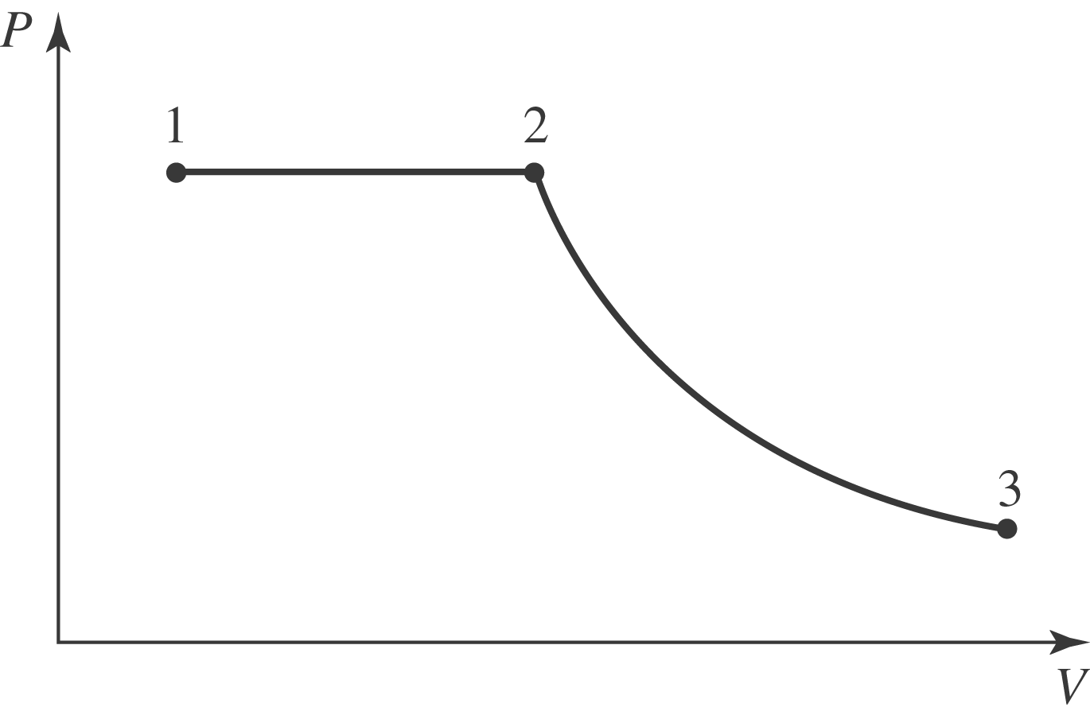

- b) The work done is
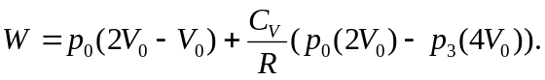
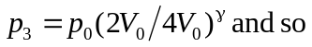
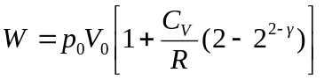
Note that 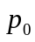is the absolute pressure. c) The most direct way to find the temperature is to find the ratio of the final pressure and volume to the original and treat the air as an ideal gas;

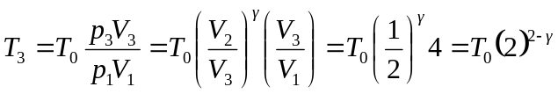
d) Since 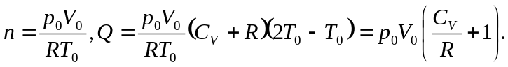This amount of heat flows into the gas.

